OSINT4Fun Advent of OSINT 2024: Day 2

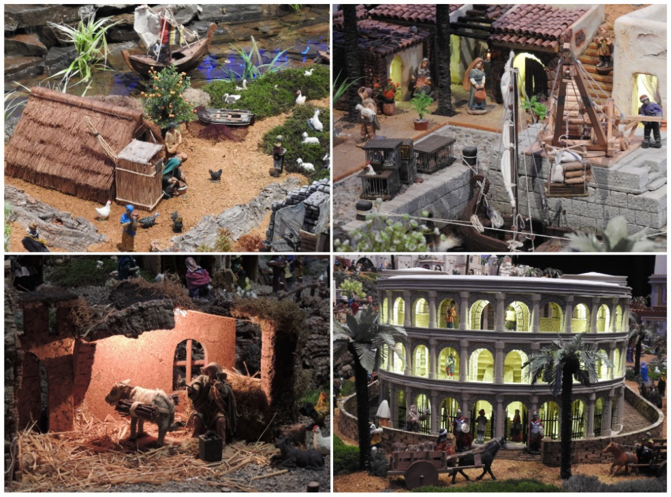

*Nativity scenes have been popular for hundreds of years. Whilst most are small, some can be quite large. The figure shows four close-up photos of a highly detailed diorama featuring a nativity scene.*

*According to the official count, how many pieces were used (at least) in the 2023 set?*

As a first step, let’s run the image through Google reverse image search. Specifically, we would focus the search on each of the four sections. When focusing on the top-left picture, the fourth resulting image seems similar to the big roof and the rectangular structure in front of it. However, clicking on this link reveals a page from shutterstock with many image results for “crib exhibition” that don’t seem to include the picture from the Google reverse image results. Therefore, I continued scrolling through the Google reverse image results to see any other images that might resemble the top-left picture. Eventually, I come across a hit from Alamy with the same picture as the fourth search result. Clicking on this link does actually reveal the image. It doesn’t seem to be an exact match to the picture we are looking for based on the location of the bird figurines, but the roof and rectangular structure (which seems to be some kind of shed) do match. This scene thus seems to be worth investigating further. The Alamy page captions the image with Vila Real Santo Antonio, Portugal – 1st January 2023. For now, I keep this in mind and continue with Google reverse image searching the other three images. The top-right picture unfortunately gives no promising results. The same goes for the bottom-left picture. The bottom-right picture actually gives multiple results that mention Vila Real in their caption. One of these results directs to a Swedish Wordpress blog that features multiple pictures from the Vila Real. The picture of the Colloseum-type building is a match for our bottom-right picture, indicated with the positioning of the palm trees as well as the horse carriage. Now that we know the name of the diorama, let’s see if we can find out how many pieces were used (at least) in the 2023 set. To find this out, I Google the following: “Vila Real” 2023 diorama. On the top of the page, I see a number of images as search results, with one from Algarve Eventos that mentions a Giant Nativity Scene in Vila Real. Clicking on this link reveals an event announcement with an associated link to cm-vrsa.pt. This website lists a news result about the 2024 Vila Real diorama edition, which mentions that this edition uses 5900 pieces. Perhaps earlier news results include an article about the 2023 edition. Eventually on page 13 I come across the same article from 2023, which mentions that this edition used 5800 pieces.